
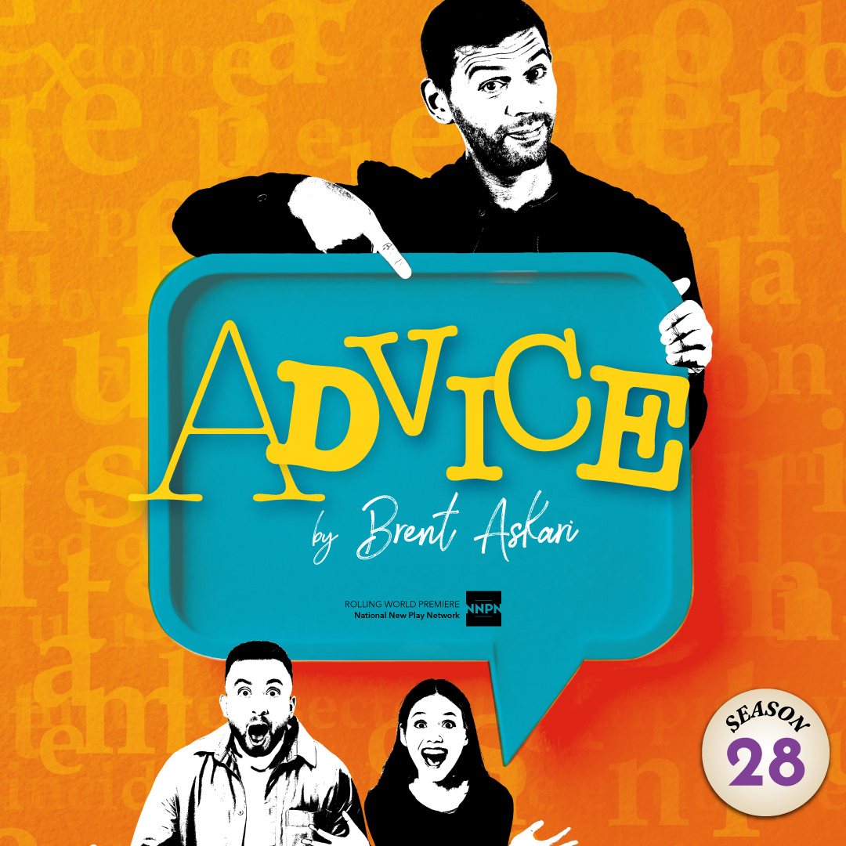 | We all have that one friend... On the eve of their anniversary, Joy and Ron hear the most ridiculous news: their idiot friend Gary has written a self-help book…and it’s getting published! As they muse on what the new book could possibly say, Gary shows up and asks them to try out some of his “couple exercises.” They beg him not to quit his day job to become a life coach, but end up uncovering secrets that throw their relationship into chaos! Florida Rep audiences will be among the first to laugh out loud at this hilarious NEW COMEDY!

TYPE YOUR GROUP INFORMATION HERE

