
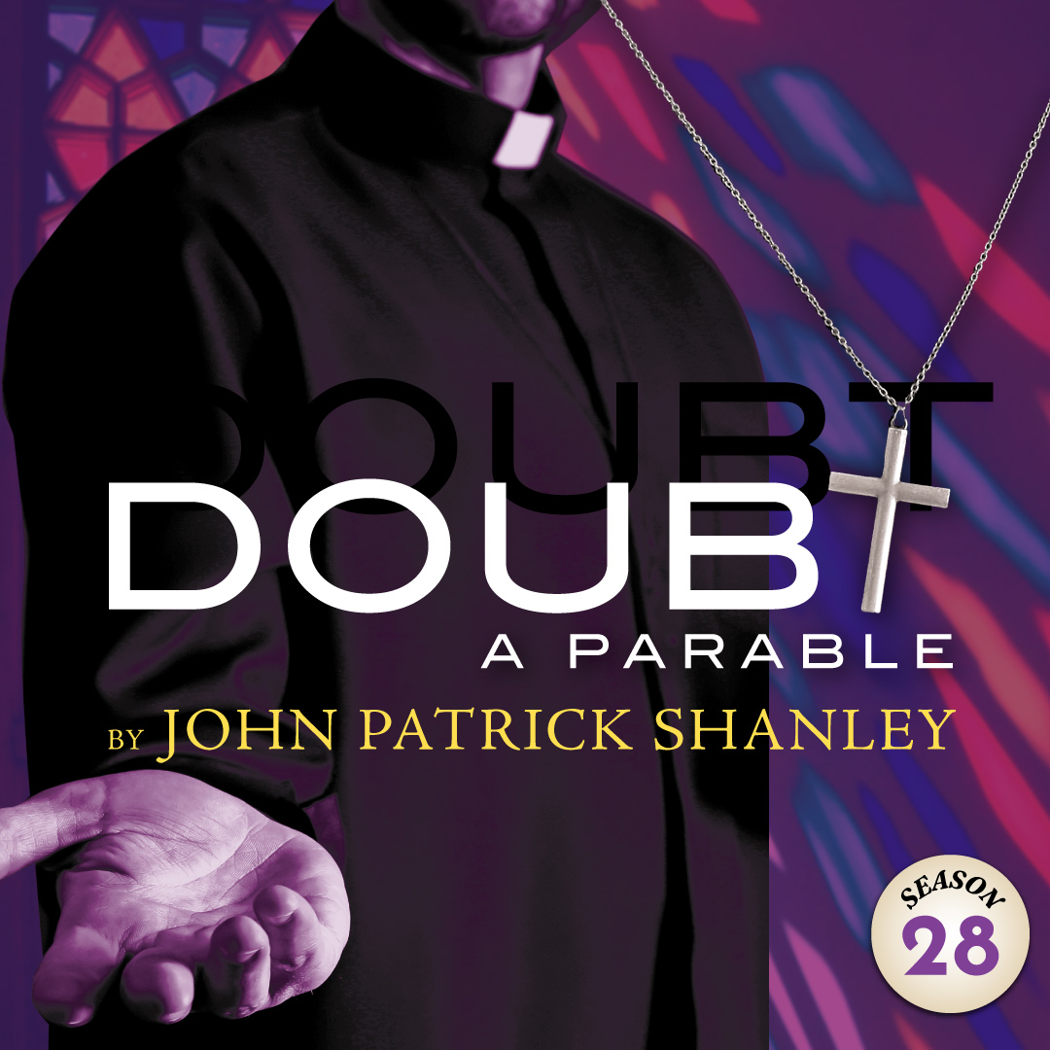 | The Pulitzer Prize & Tony Winning BEST PLAY! A powerful, electrifying, and explosive drama takes the Arcade Theatre by storm. The fireworks begin as the exacting principal of a Bronx Catholic school suspects improper relations between a charismatic priest and a student. She’s forced to wrestle with what’s fact, what’s fiction, and just how far she’ll go to expose what she sees as the truth. “It keeps the audience guessing and second-guessing through the play’s famous final line.” -New York Post

TYPE YOUR GROUP INFORMATION HERE

