
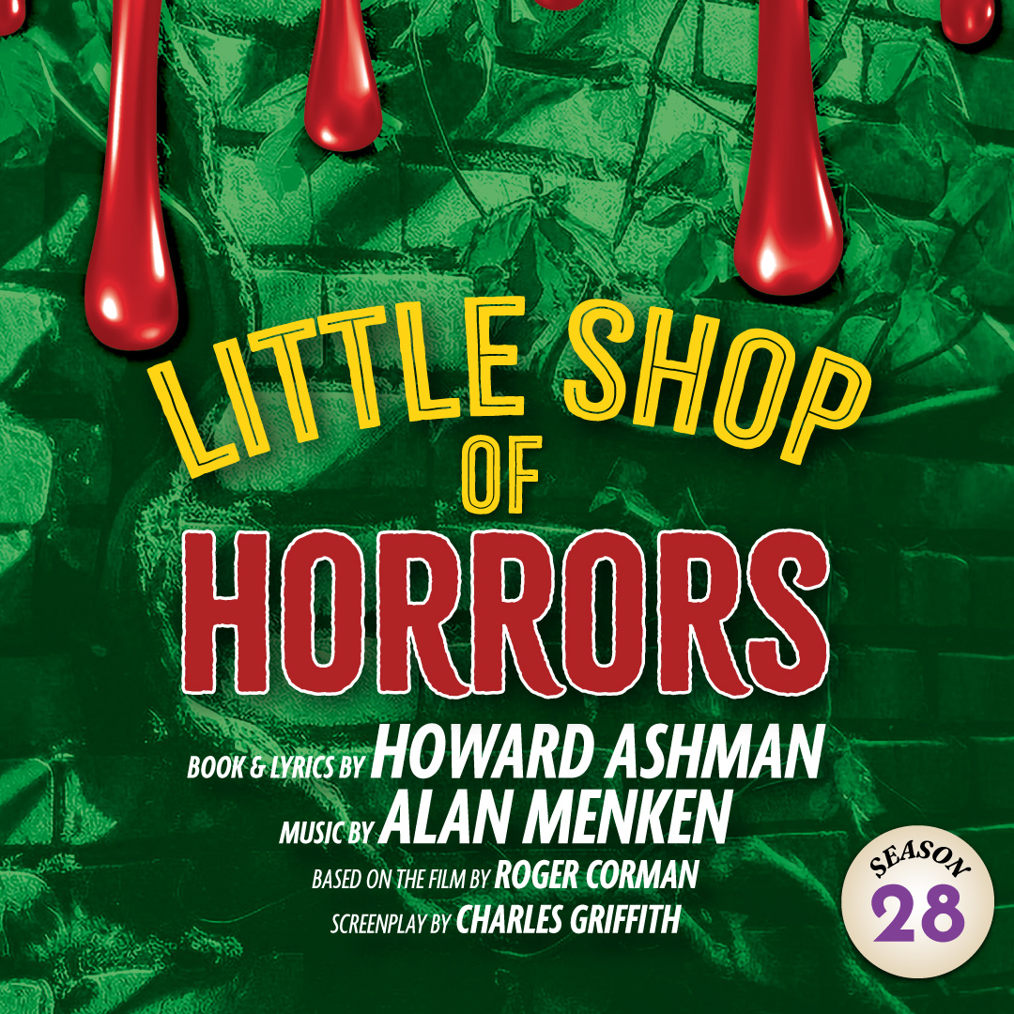 | A deviously delicious American cult classic! At Mushnik’s Skid Row Florist, down-on-his-luck Seymour pines for his beautiful coworker, Audrey (who is trapped in an abusive relationship with a masochistic dentist). When Seymour stumbles across a strange and  interesting new plant – with an unquenchable thirst for human blood – it looks like all his dreams may come true. Based on a 1960s B-Movie, Little Shop is packed with laughs, thrills, chills, and all the hit songs it made famous – “Skid Row,” “Feed Me”, “Suddenly  Seymour,” and more!

TYPE YOUR GROUP INFORMATION HERE

