
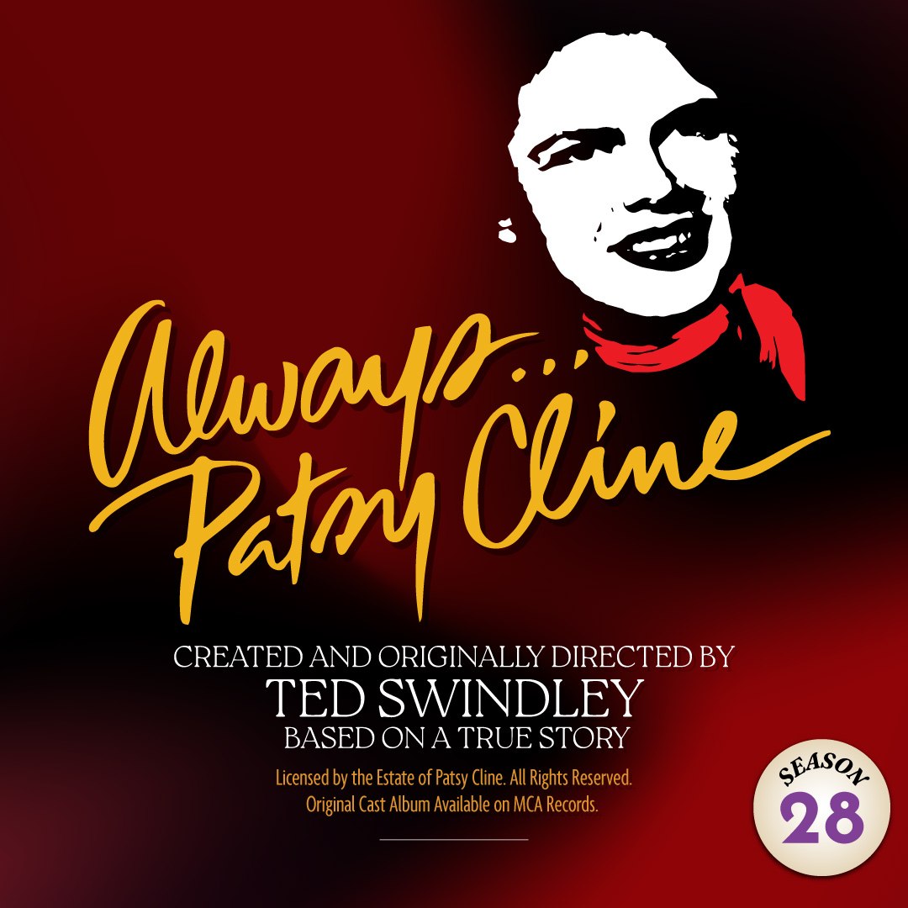 | The country music sensation is BACK by popular demand! This heartfelt and powerful true story celebrates the most popular female country singer in recording history. Patsy Cline’s legendary voice and rise to stardom took America by storm, and this loving tribute is told through the eyes of her biggest fan and unlikely friend, Louise Seger. The Arcade comes to life with Patsy’s biggest hits, including “Crazy,” “Walkin’ After Midnight,” “I Fall to Pieces,” and more!

TYPE YOUR GROUP INFORMATION HERE

