
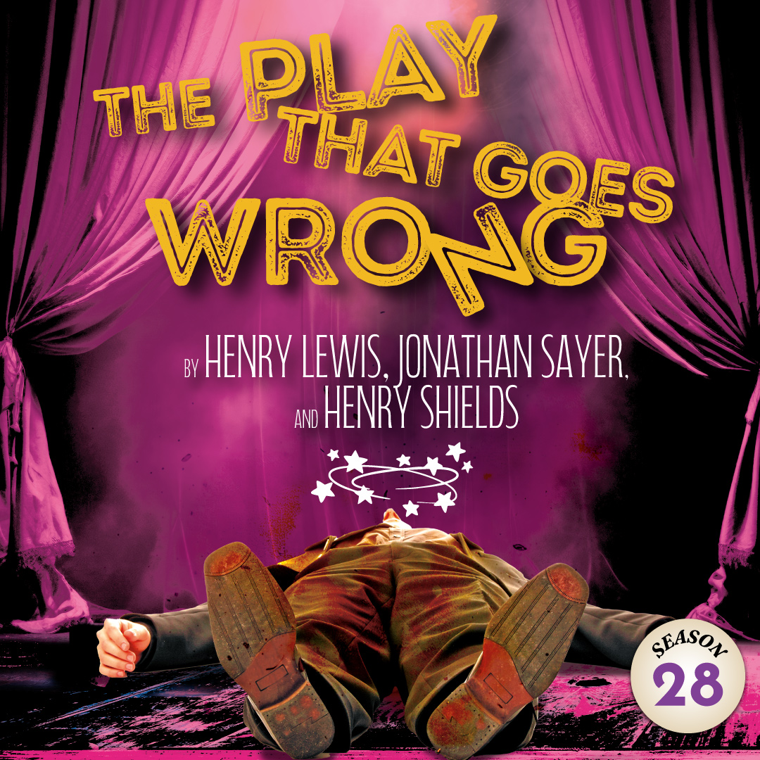 | This Olivier Award-winning comedy is a hilarious hybrid of Monty Python and Sherlock Holmes. Welcome to opening night of The Murder at Haversham Manor where things quickly go from bad to utterly disastrous. Among the challenges, are an  unconscious leading lady, a corpse that can’t play dead, and actors who trip over everything (including their lines). Nevertheless,  the accident-prone thespians battle against all odds to make it through to their final curtain call, with hilarious consequences!

TYPE YOUR GROUP INFORMATION HERE

