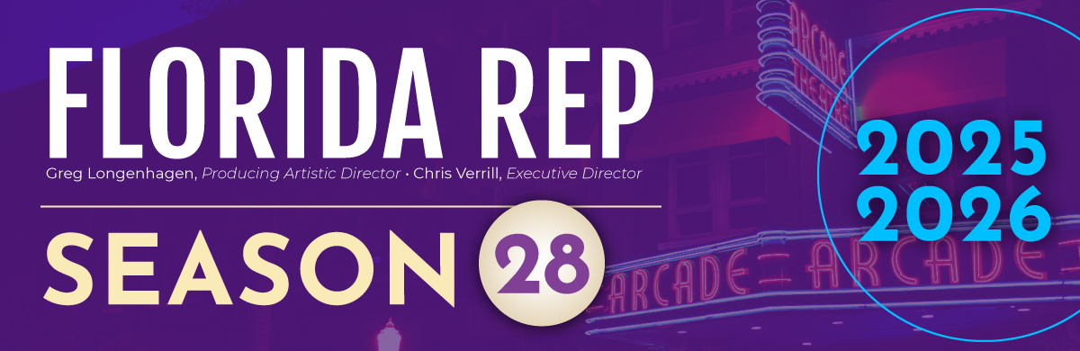
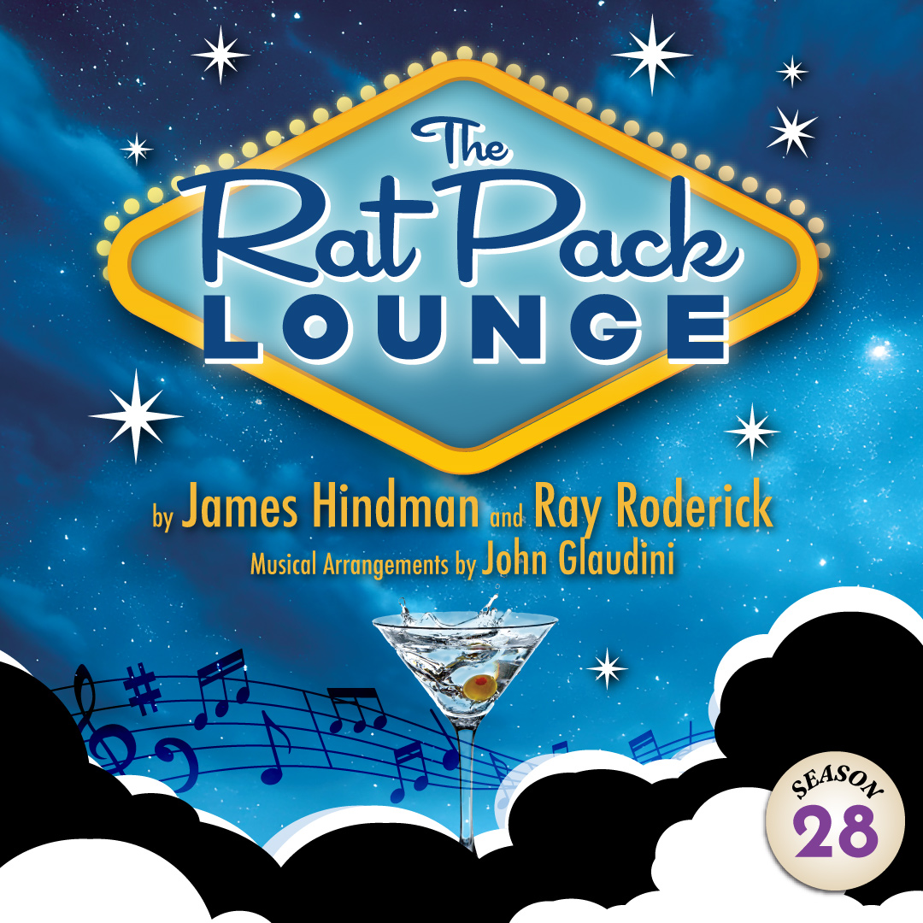 | Frank, Dean, and Sammy are up in heaven, but God tells them they left some unfinished business... It seems Frank made an unfulfilled promise to the owner of the Rat Pack Lounge. Now he and the boys have one night to make things right. This fresh and funny musical revue includes over 30 hit songs, including “My Way,” “What Kind of Fool Am I?” and “Everybody Loves Somebody Sometime.” “No matter the decade in which you were born, if you love music, this is a show you won’t want to miss.” -BroadwayWorld

TYPE YOUR GROUP INFORMATION HERE

