
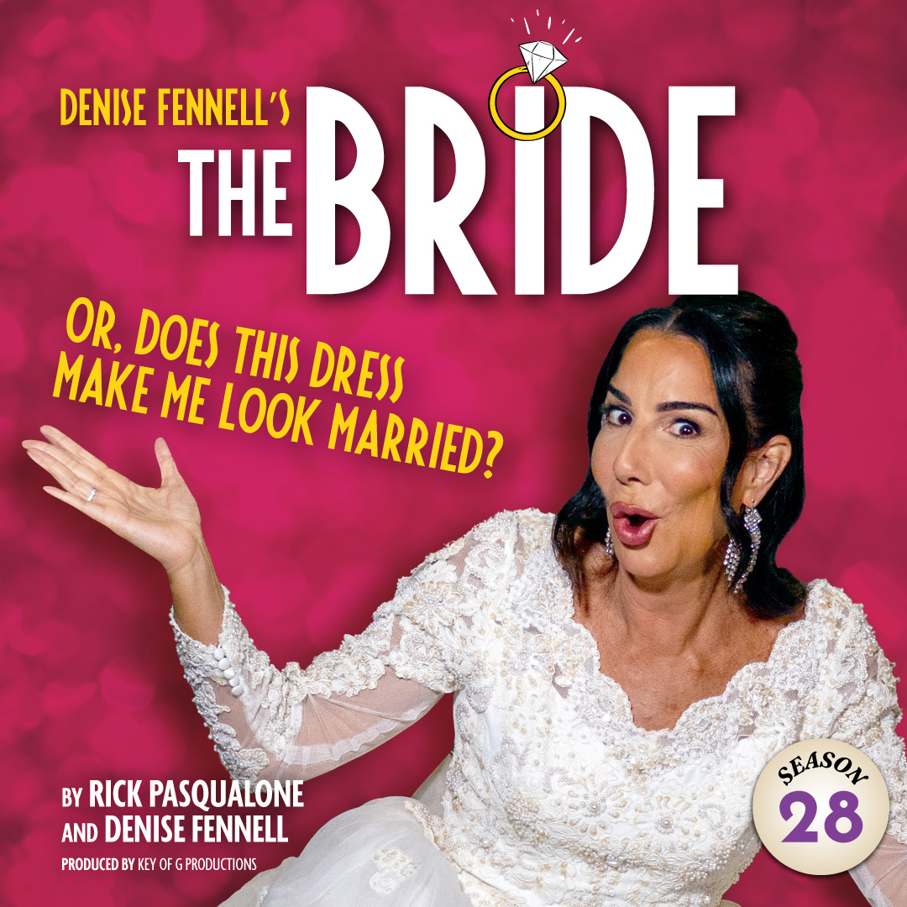 | A one-woman-tour-de-force starring Denise Fennell, the scrappy Sister from last summer’s Late Nite Catechism! With less than  two hours until her wedding, a bride of a certain age begins to question the meaning of love, life, and the ritual of marriage.  Drawing inspiration from her own life and the advice of the audience, The Bride leads to the decision of a lifetime: Will she, or won’t she? “Denise Fennell captivates audiences with joy and sentimental reflection” -BroadwayWorld

TYPE YOUR GROUP INFORMATION HERE

