
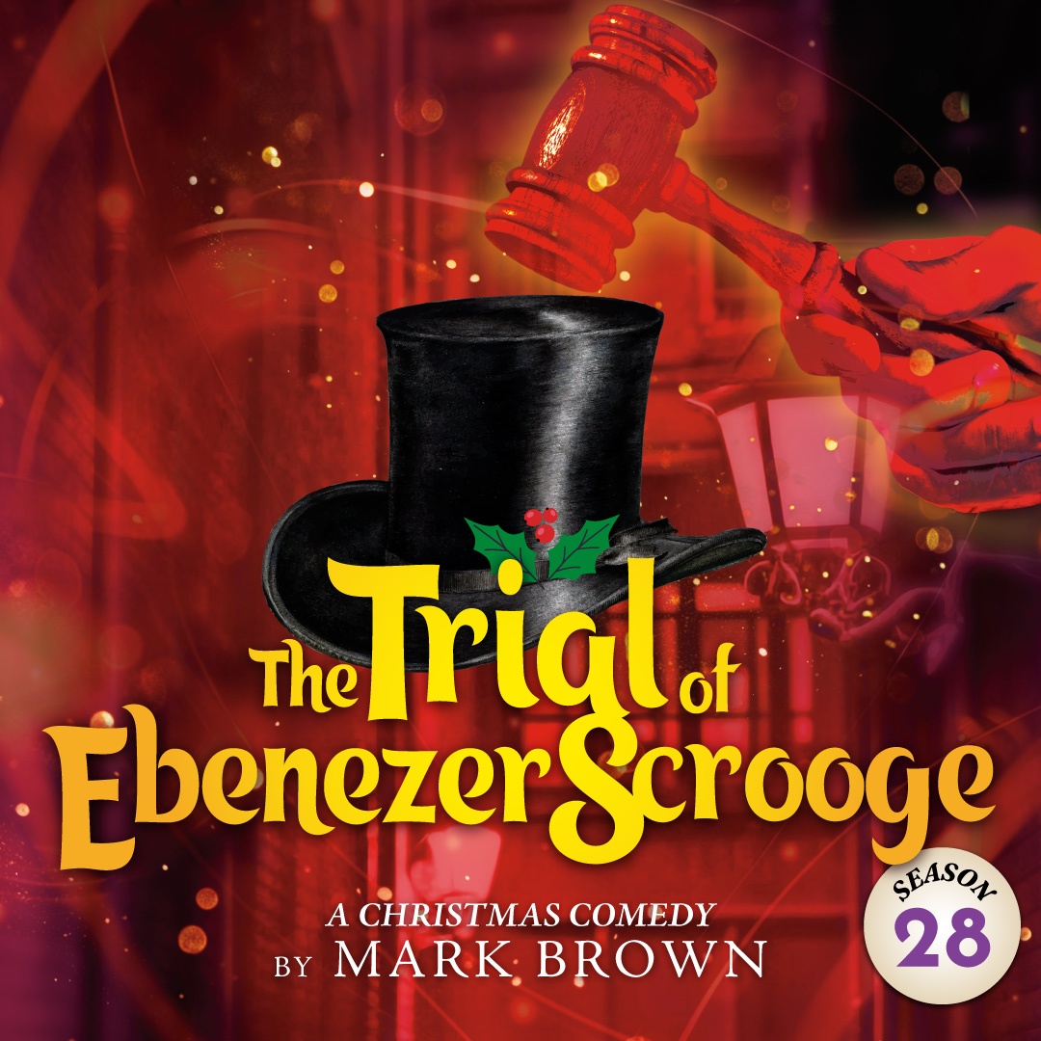 | A delightful and zany holiday comedy from the author of Around the World in 80 Days. A year after his miraculous transformation, Ebenezer Scrooge is back to his old ways and is suing Jacob Marley and the Ghosts of Christmas Past, Present and Future for breaking and entering, kidnapping, slander, pain and suffering, attempted murder and the intentional infliction of emotional distress. An ingenious and joyous holiday event for the whole family! “Clever and full of heart!”-Allentown Morning Call

TYPE YOUR GROUP INFORMATION HERE

