
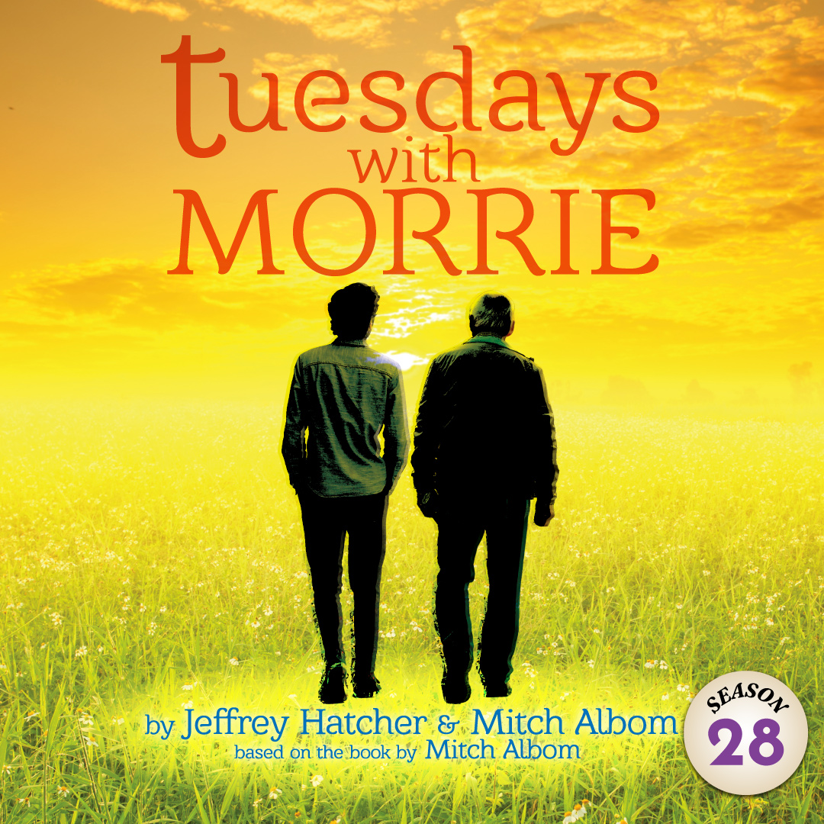 | The moving autobiographical story of Mitch Albom, an accomplished, career driven journalist, and Morrie Schwartz, his former college professor, comes to heartbreaking life. Sixteen years after graduating, Mitch catches his old professor’s appearance on TV news show, and learns Morrie is battling Lou Gehrig’s Disease. Mitch drops in to catch up, and what starts as a simple visit turns into a weekly pilgrimage and a last class in the meaning of life.

TYPE YOUR GROUP INFORMATION HERE

